**COFFEE SALES SQL QUERIES**

**1. how many people in each city are estimated to consume coffee, given that 25% of population does?**

SELECT city_name,ROUND((population*0.25)/1000000 ) as c_consumer_mln,city_rank

FROM city ORDER BY population DESC;

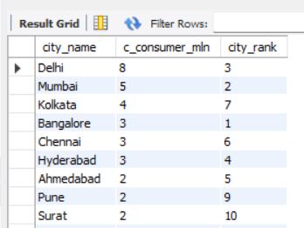

**2. TOTAL REVENUE FROM COFFEE SALES?**

SELECT ci.city_name,sum(s.total) as total_revenue FROM sales as s

JOIN customers as c

ON s.customer_id=c.customer_id

JOIN city as ci

ON c.city_id=ci.city_id

WHERE quarter(s.sale_date)=4 and YEAR(s.sale_date)=2023

GROUP BY ci.city_name

ORDER BY SUM(s.total) DESC;

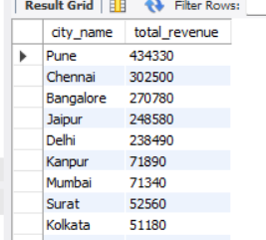

**3. HOW Many units of each coffee product has been sold?**

SELECT p.product_name,count(s.sale_id) as total_orders FROM products as p

LEFT JOIN sales as s

ON s.product_id=p.product_id

GROUP BY p.product_name

ORDER BY total_orders DESC;

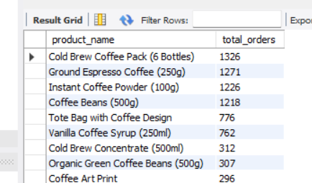

**4. avg sales amount per customer in each city?**

SELECT ci.city_name,sum(s.total) as total_revenue,COUNT(DISTINCT(s.customer_id)) as total_customer,round(sum(s.total)/COUNT(DISTINCT(s.customer_id)),1) as avg_per_cust FROM sales as s

JOIN customers as c

ON s.customer_id=c.customer_id

JOIN city as ci

ON c.city_id=ci.city_id

GROUP BY ci.city_name

ORDER BY SUM(s.total) DESC;

**5 city population and coffee consumers(list of cities with their population,coffee consumers)?**

WITH my_cte as(SELECT city_name,ROUND((population*0.25)/1000000 ,2) as c_consumer_mln FROM city),

cust_table as (select ci.city_name,count(distinct(c.customer_id)) as unique_cust

FROM sales as s

JOIN customers as c

ON c.customer_id=s.customer_id

JOIN city as ci

ON ci.city_id=c.city_id

GROUP BY ci.city_name)

select ct.city_name, ct.c_consumer_mln, cit.unique_cust

from my_cte as ct

JOIN cust_table as cit

ON cit.city_name=ct.city_name;

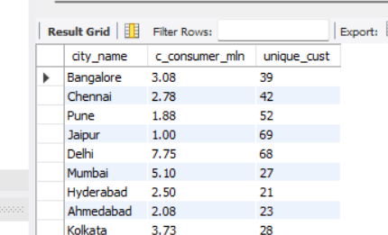

**6.how many unique customers are there in each city who have purchased coffee product?**

select ci.city_name,count(distinct(c.customer_id)) as unique_cust

FROM city as ci

LEFT JOIN customers as c

ON c.city_id=ci.city_id

JOIN sales as s

ON s.customer_id=c.customer_id

JOIN products as p

ON p.product_id=s.product_id

WHERE s.product_id IN (1,2,3,4,5,6,7,8,9,10,11,12,13,14)

GROUP BY ci.city_name;

***Output:***

**7.calculate percentage growth in sales over different time periods by each city?**

WITH MONTHLY_SALES AS (SELECT ci.city_name,MONTH(sale_date) as month, YEAR(sale_date) as year,sum(s.total) as total_sales FROM sales as s

JOIN customers as c

ON c.customer_id=s.customer_id

JOIN city as ci

ON ci.city_id=c.city_id

GROUP BY ci.city_name,MONTH(sale_date), YEAR(sale_date)

ORDER BY ci.city_name, YEAR(sale_date),MONTH(sale_date) ASC

),

growth_ratio AS (

SELECT

city_name,

month,

year,

total_sales as cr_month_sales,

LAG(total_sales,1) OVER(PARTITION BY city_name ORDER BY year,month) as last_month_sales

FROM MONTHLY_SALES)

SELECT

city_name,month,

year,

cr_month_sales,

last_month_sales,

ROUND((cr_month_sales-last_month_sales)/last_month_sales*100,2)as growth_ratio

FROM growth_ratio

WHERE last_month_sales IS NOT NULL;

***Output***

